1950s – Early Computer Use in Healthcare
- Short Narrative:
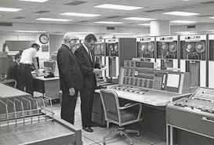
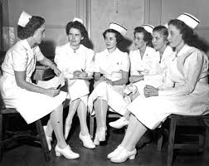
During the 1950s, healthcare institutions began experimenting with computers to improve hospital administration and data management. Although computers were large and expensive, they helped automate basic tasks such as billing and record keeping, laying the foundation for future healthcare technology.

- Highlights
  - Hospitals started using computers for administrative tasks.
  - Automation of financial and record-keeping systems began.
- Important Inventions/Developments
  - Mainframe computers
  - Electronic data processing systems
  - Early hospital billing systems
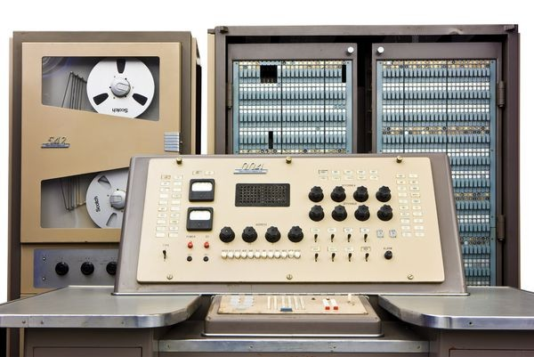
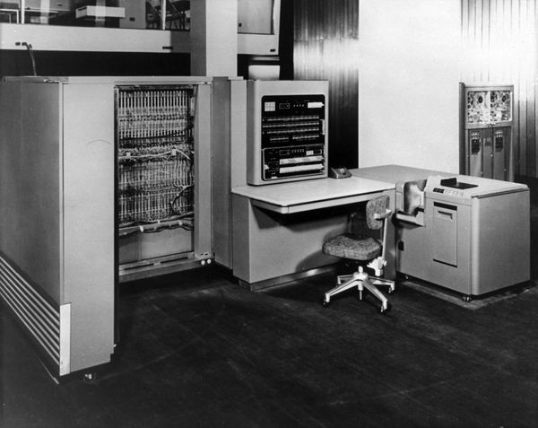

1960s – Introduction of Hospital Information Systems
- Short Narrative:
In the 1960s, hospitals increasingly adopted computerized systems to organize patient information and improve efficiency. Technology began supporting healthcare operations beyond finance, including scheduling and laboratory services.
- Highlights
  - Growth of computerized hospital systems
  - Increased efficiency in healthcare operations
- Important Inventions/Developments
  - Hospital Information Systems (HIS)
  - Computerized patient scheduling systems
  - Laboratory information systems
1970s – Birth of Nursing Informatics
- Short Narrative:
The 1970s marked the emergence of Nursing Informatics as nurses recognized the importance of computers in improving patient care and nursing documentation. Nursing education also started incorporating computer-related learning.
- Highlights
  - Emergence of the term “Nursing Informatics”
  - Growing interest in computer-assisted nursing practice
- Important Inventions/Developments
  - Electronic nursing documentation
  - Nursing databases
  - Computer-assisted instruction programs
- Key People
  - Harriet Werley - a pioneer in nursing informatics known for promoting standardized nursing data and computerized information systems to improve nursing research and patient care.
  - Virginia Saba - a leader in nursing informatics who developed the Clinical Care Classification (CCC) System and helped improve electronic nursing documentation and healthcare communication.
1980s – Recognition of Nursing Informatics
- Short Narrative:
During the 1980s, Nursing Informatics became officially recognized as a nursing specialty. Personal computers became more accessible, allowing nurses to use computerized systems directly in clinical practice.
- Highlights
  - Official recognition of Nursing Informatics
  - Increased computer use in nursing care
- Important Inventions/Developments
  - Personal computers in hospitals
  - Clinical Decision Support Systems (CDSS)
  - Computerized nursing care plans
- Major Event
  - In 1982, the American Nurses Association recognized Nursing Informatics as a specialty.
1990s – Expansion of Electronic Health Records
- Short Narrative:
The 1990s saw rapid technological growth with the rise of the internet and electronic health documentation. Hospitals shifted from paper records to digital systems, improving communication and access to patient information.
- Highlights
  - Expansion of electronic documentation
  - Increased internet use in healthcare
- Important Inventions/Developments
  - Electronic Health Records (EHRs)
  - Telemedicine systems
  - Barcode medication administration
  - Internet-based healthcare communication
- Major Contributions
  - Standardized nursing languages:
  - NANDA
  - NIC
  - NOC
2000s – Modernization of Healthcare Technology
- Short Narrative:
In the 2000s, healthcare technology became an essential part of nursing practice. Nurses relied more on digital tools to support evidence-based practice, patient safety, and efficient healthcare delivery.
- Highlights
  - Technology integrated into daily nursing practice
  - Greater focus on patient safety and evidence-based care
- Important Inventions/Developments
  - Wireless healthcare technology
  - E-prescribing systems
  - Smart infusion pumps
  - Patient portals
2010s – Digital and Mobile Health Era
- Short Narrative:
The 2010s introduced mobile and cloud-based healthcare technologies that improved accessibility and communication. Nurses increasingly used mobile devices, telehealth, and wearable technologies to monitor and care for patients.
- Highlights
  - Expansion of telehealth services
  - Increased use of mobile healthcare technology
- Important Inventions/Developments
  - Mobile health apps (mHealth)
  - Cloud-based medical records
  - Wearable health devices
  - Big data analytics
  - Artificial intelligence applications

